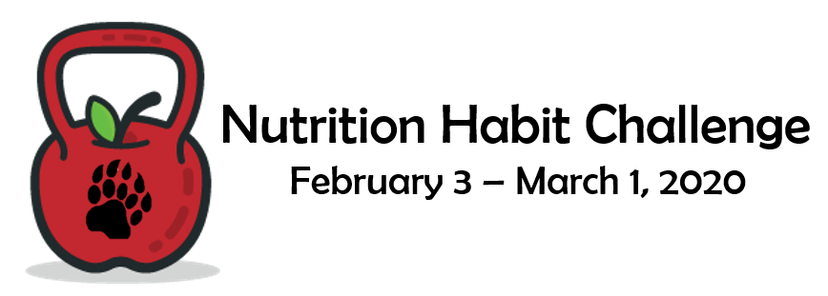

**Join the BASD Wellness Committee for the Nutrition Habit Challenge …**

**and become eligible to win “healthy” prizes!**

The objective of the Nutrition Habit Challenge is to educate, motivate and inspire our staff, students, and community to take personal responsibility for improving health habits. Our hope is that you become an advocate for the Challenge by participating and encouraging your family and friends to do the same.

By participating in the Challenge, you win by making a positive change to your diet/lifestyle and be entered into drawing for “healthy” prizes.

Here is how it works:

* Register for the Challenge ([here – NHC Registration](https://docs.google.com/forms/d/e/1FAIpQLSdHEReduVzeoHUur3Z-Pfcpivgfj59hrD2g19ppEtVzvWxakQ/viewform?usp=sf_link)) by 2/2/20. Registration is free and simple.
* Commit to one nutritional behavior you would like to change. You can choose from a list of nutritional behaviors ([Nutritional Commitments](https://drive.google.com/a/student.boyertownasd.org/file/d/1YnA9WwHBKupsinNC0L1zOJ_wa6VJqS32/view?usp=sharing)) or come up with your own.
* Keep track of all days you successfully practice your nutritional behavior between the dates of February 3rd and March 1st. If you are successful for 25 out of 28 days, you become eligible for the prizes.
* Email your score card ([NHC Scorecard](https://drive.google.com/a/student.boyertownasd.org/file/d/1e-MH4IoDah7AfcDyXcOR8vEKHpA6uMVv/view?usp=sharing)) to [wellness@boyertownasd.org](mailto:wellness@boyertownasd.org) or send to the Ed. Center (Attn to Lucie Bergeyova)
* Find more information at <https://www.boyertownasd.org/Page/5628>
* Winners will be announced on 3/11/20.

Get your family together and discuss what each of you can do to make healthier nutrition choices. From there, make simple commitments, get registered, and hold each other accountable. Not only will it be fun, but also you will be modeling personal responsibility and leadership for those you love. It is also an opportunity to model and practice integrity...the Challenge is done on the honor system.

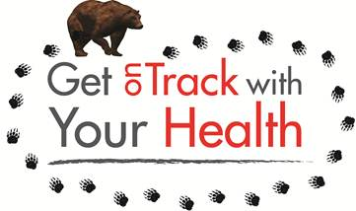We hope we can count on your active support.

Thank you.

The BASD Wellness Commitee